**Exam Blueprint**

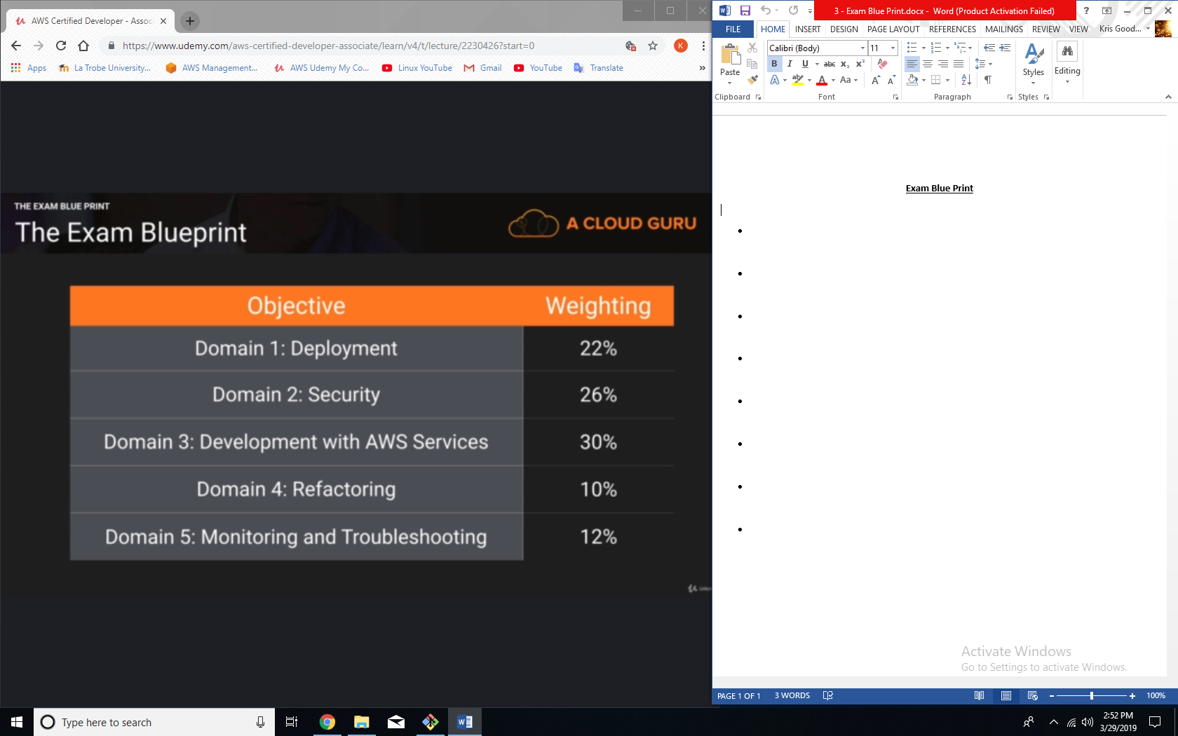

**About the exam:**

* Exam is entirely multiple choice questions.
* 130 Minutes in length
* 65 questions
* Results immediately
* Pass mark is 720. Top score is 1000
* $150 USD
* Qualification is valid for 2 years.

**Exam tips:**

* If exam asks if you should use keys or roles, always use roles.